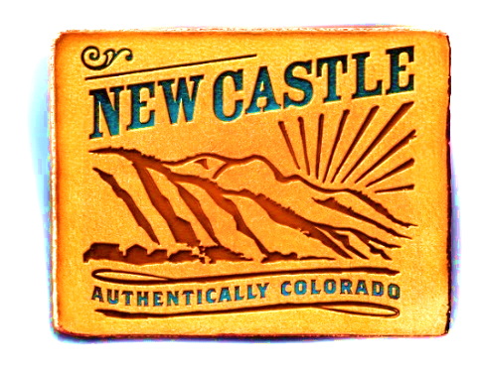bvvv

Town of New Castle

Newsletter

A Monthly Update for Residents

**May 2022**

**New Castle Emergency Preparedness**

Wildfire season in Colorado can affect us all. If a fire or other emergency should require evacuation of town residents, it is important to know what to do. Please note that following instructions from law enforcement/traffic control personnel is critical to not only your safety but that of others. Please heed their guidance in an emergency.

The first step is preparedness. 1) Sign up for emergency notification at www.garco911.org. 2) Make an emergency contact list for everyone in your home to carry and designate a place to meet. 3) Prepare a go bag for everyone in the home. Make sure that this is prepared ahead of an emergency. 4) Be aware of all the exits from town, highlighted on the map below. 5) Plan to attend *Firewise: Ready, Set, Go* presented Colorado River Fire Rescue at CMC Rifle on May 28th from 10:00 am – 3:00 pm. Sign up for the free class on the college’s website.

Stay tuned each month throughout the summer for information from New Castle’s Public Information Officer, Rochelle Firth. Direct questions to rfirth@newcastlecolorado.org.

**May 7 is a Full Day in New Castle**

Saturday, May 7, kicks off with the **Hogback Hustle.** The 5K race starts at the City Market parking lot at 9:00 am, then snakes through town and ends at Burning Mountain Park with breakfast and awards. The cost is $35, benefitting the New Castle Recreation Department and the Youth Scholarship Program. Register at newcastlerec.com and contact the Recreation Department with questions (970-984-3352).

Also on May 7 is the annual **Youth Fishing Derby** presented by the New Castle Cub Scouts. Everyone is asked to pre-register at newcastlerec.com, then arrive at Alder Park Pond promptly at 9:30 am to check in. This free event requires a brief “Learn to Fish” lesson that must be taken before fishing begins. Fishing in age groups will be staggered between 9:30 am and 2:00 pm. Thanks to Wendy’s, everyone who registers will receive a free frosty. Grease Monkey is a Gold Sponsor this year.

May 7 is the date for the **Annual Town-Wide Yard Sale** beginning at 8:00 am. Participants are asked to put up and remove their own yard sale signs. Everyone is also asked to be patient with the increased traffic through town. Note that all traffic will be halted on Castle Valley Boulevard, Midland Avenue, 7th Street and Main Street between 9:00 am and 10:00 am for the Hogback Hustle.

Finally, **Symphony in the Valley** returns to present “Symphony Swing” on Saturday, May 7, at 6:30 pm at New Hope Church. The concert is the Symphony’s annual fundraiser and features Big Band music from the Roaring Twenties, with dancing and dinner catered by Stoney Joanie’s.

.

**TOWN OF NEW CASTLE * 970 984-2311 * www.newcastlecolorado.org**

**OWN OF NEW CASTLE * 970 984-2311 * www.newcastlecolorado.org**

**TOWN OF NEW CASTLE * 970 984-2311 * www.newcastlecolorado.org**

**Graduation Month is Here**

May is an exciting month for high school and college students as graduation approaches. The Town of New Castle congratulates each one of you for your outstanding achievements and wishes you all the best of luck for the future.

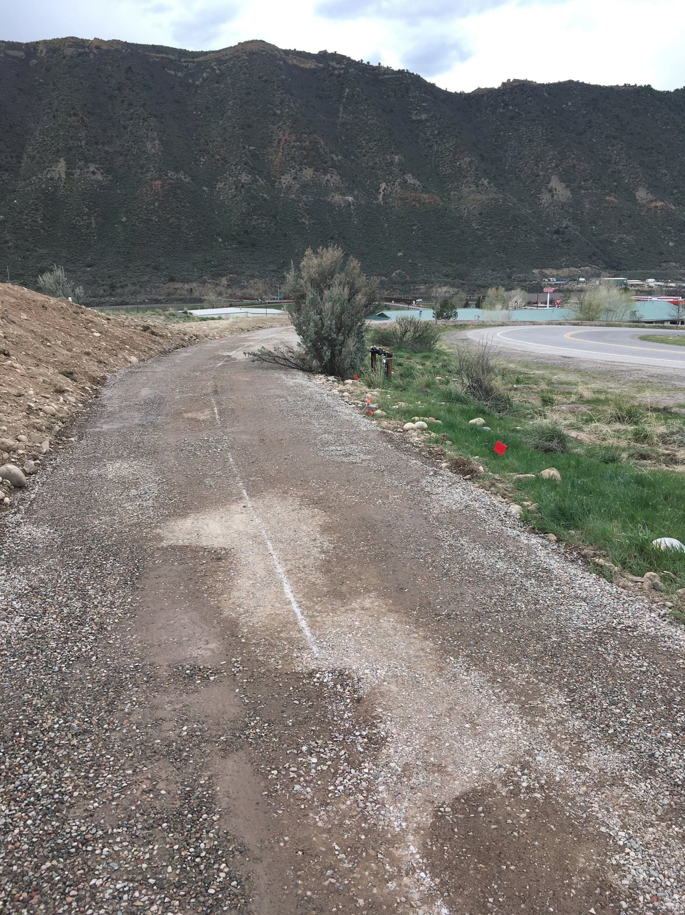

‘

Town of New Castle Public Works is busy building a trail from the Shibui Apartments to the City Market Plaza.

**New Castle’s Historic Preservation Commission Subgrant Award for 2022**

The Town’s Historic Preservation Commission is a member of the state’s Certified Local Government program through History Colorado. This program provides opportunities and resources to local municipal historic commissions, including subgrants for historic surveys.

The New Castle Historic Preservation Commission and Commission Clerk Remi Bordelon applied for a grant in late 2021 to fund a historic survey of Main Street and other designated properties. The grant application was approved for survey work to be completed this year.

This opportunity affords the commission the ability to review properties for historic designation as well as to update the town’s original 1996 survey.

**New Castle Fire Restrictions in Effect**

The Town Code restricts outdoor burning, fireworks and spark producers every year from April 1 to November 1. Please see the town website under “In the News” for more information.

The BLM and county officials have noted that spring rain has stimulated grass and weed growth, which will fuel fires if it is not controlled. The town is asking residents to please keep grass trimmed, as well as to remove flammable materials stored outside.

Let’s all do our part to prevent more fires this summer.

**New Castle’s April 5 Election Results**

At New Castle’s April 5, 2022, regular election, Mayor Art Riddile was re-elected, and Bruce Leland, Brandy Copeland and Caitlin Carey were elected to Town Council seats. All were sworn in at the April 19 Town Council Meeting. Outgoing Council Member Scott Owens was thanked for his contributions to the town as his term expired.

Ballot Issue A, the lodging tax, passed, increasing the town lodging tax on hotel/motel and VRBO/Air B-n-B type rooms from 2.5% to 5% beginning in January 2023.  New Castle has 3,037 registered voters. 730 ballots were cast which equals a 24.04% voter turnout.

Designated Election Official, Town Clerk Melody Harrison, Deputy Town Clerk Mindy Andis and Administrative Assistant Remi Bordelon began preparing for the election in December 2021 in accordance with state election law. Six election judges were selected and trained and they began the process of signature verification in late March. Two employees from the Garfield County Elections office assisted and used counting machines that electronically scanned the ballots and counted the votes.

**Did You Know That…..**

Colorado Drifters Coffee Shop hosts a free Open Mic Night the first Thursday of each month.

St. Mary’s bloodmobile will return on Friday, May 20th from 11:00 am – 1:00 pm in front of the library.

New Castle Cub Scout Pack 221 will observe Memorial Day on May 31 at 10 am in Highland Cemetery.

Local businesses and business owners took 31 awards in the Post Independent’s Locals Choice Awards. Burning Mountain Park and the Chili Cook-off also took awards.

The New Castle Running Club runs every Monday evening. Find them on Facebook and join the next run.

The River Center is recruiting volunteers. Please call 970-984-4333 to sign up.

The community gardens at Apple Tree and the River Center have plots available. Call 970-984-4333.

EverGreen ZeroWaste will begin operation in town in May Sign up at https://ebergreenzerowaste.com

Town Hall will be closed on Memorial Day, May 31.

All dogs must be leashed in town.

**TOWN OF NEW CASTLE * 970 984-2311 *www.newcastlecolorado.org**

**www.newcastlecolorado.org**

**New in New Castle: Wrap and Roll Deli**

Ritter Plaza has welcomed a new business, Wrap and Roll Deli, owned and operated by Anabel Meza along with son Jesus and daughter Alejandra.  
A new resident of New Castle, Anabel has been wanting to open her   
own deli for years. After working at Upper Crust Bakery in El Jebel for many years, Anabel knew that this was the kind of business she wanted to bring to her hometown. Her son Jesus, now 22, thought it was the perfect time to go after this dream when they found a space vacant in Ritter Plaza.

Jesus explained, “Everything we make for you is made with love. We will only serve homemade bread for your sandwiches, made from scratch pastries, croissants, bagels, muffins,cinnamon rolls, and at some point homemade soups. Wrap and Roll Deli also has ice cream, fruit smoothies made with real fruit juice as well as espresso and lattes. Please stop by and give us a try. We promise you won’t be disappointed.”

The new deli is located at 295 W Main Street. Hours are 6:00 am - 5:00 pm, seven days a week.



**From the Chamber**

The Chamber’s Business of the Month, Spirits of New Castle, has been a fixture in downtown since Jim and Kristi Wirt purchased the business, located at 302 West Main, just before Thanksgiving 2006. Jim, an electrician who owns Tradesman Electric, and Kristi, a former bookkeeper, are proud parents of two grown sons and five grandchildren. Besides being with their family, the Wirt’s enjoy hanging out with friends. Spirits is a full-service liquor store offering an array of wine, beer and spirits. Kristi says they’re also happy to place special orders for customers. Kristi says the hardest part of business right now is finding employees, though she is quick to add that her long time crew of Deb, Robin, Renee, Ali and Margie make business at the store run smoothly.

Spirits is proud of their selections of craft beers, adding that they also try to support Colorado products. Spirits also carries a selection of unique gifts and cards. Kristi loves the old and new friends she sees at the store and hopes that the revitalization of downtown New Castle will bring more people to the area. Spirits posts specials on their Facebook page, and they invite everyone to “Like” the page. They can be reached at 970-984-3225, or in person at the store.

**New Castle Chamber of Commerce “Growing Businesses, Building Community”**

**TOWN OF NEW CASTLE * 970 984-2311 * www.newcastlecolorado.org**

**New July 4th Celebration in New Castle**

The Freedom Celebration at Apple Tree has been discontinued. In its place, New Castle will celebrate Independence Day on Monday, July 4, with an old-fashioned non-motorized mini parade at the Elk Creek Elementary School grounds. Kids and adults are invited to join the parade with decorated bikes, scooters, little red wagons, strollers, leashed (and crowd-friendly) pets, horses, goats, alpacas, anything that’s not motorized. The parade will be followed by an old-fashioned picnic. The Recreation Department will barbecue hot dogs, and participants are invited to bring additional food, drinks and picnic blankets.

Sign up now at newcastlerec.com and look for more details in the June Newsletter.

**Council Highlights**

Approved a Special Event Liquor License for Symphony in the Valley

Resolution TC 2022-12 - Approving a Conditional Use Permit for Alpine Moving and Storage

Resolution TC 2022-11 – In support of Ukraine

Ordinance TC 2022-4 – Amending Sections 16.04.060 and 17.104.020 of the Municipal Code

Read Arbor Day Proclamation

Thanked Scott Owens for six years of service on Town Council

Swore in newly elected officers: Mayor Art Riddile, Council Member Caitlin Carey, Council Member Brandy Copeland and Council Member Bruce Leland

Reappointed Myrna Candreia, Jeanne Brown and Tom Elder to Climate and Environment Commission

Reappointed Julie Martinez, Mark McDonald and Chuck Apostolik to Planning & Zoning Commission

Reappointed Bronwyn Rittner and Rick Parks to alternate seats on Planning & Zoning Commission

Reappointed Amanda Maurer as Municipal Judge

Nominated Council Member Grady Hazelton as Mayor Pro Tempore

Approved a Trail License Agreement with Garfield RE-2 School District

Earth Day events at City Market had an excellent turnout, in spite of the weather.